Reviewer: 1  
  
Comments to the Author  
This manuscript examines the fitness consequences of different segregation distorter (SD) alleles on fitness in D. melanogaster. This is an interesting question to investigate as, despite the transmission advantage of distorters, allele frequencies are low in natural populations (t-paradox) – implying there is a fitness cost to SD carrying individuals. The authors examine fitness of 3 alleles of SD, both in homo- and heterozygotes, the latter of which is particularly interesting as it has rarely been studied despite being crucial for understanding the evolutionary dynamics of SD and other distorters, making this study a valuable contribution to the literature. The study is well written and clear.  
  
The experiments the authors present are nice, and although experiment 1 has a small flaw, it still data useful to examine the question, and the flaw (caused by unexpected recombination) is covered by experiment 2. The authors are also up front about the limitation of experiment 1 which is good to read.  
  
The authors present an evolutionary model of SD, including the idea that parent of origin and sex-ratio may influence SD (based on their findings). The authors use simulations to explore the parameter space, however it is not clear to me if the model they provide is sufficient to explain the low allele frequencies of SD alleles seen in nature with the estimates of each of these parameters they obtain from their data. I.e. what range of allele frequencies do you get for each of the SD alleles if you plug in your experimental values? Do these match what is seen in nature? Are they closer to the values predicted with models that ignore these effects? I think providing these data would strengthen the paper as it would make it clear how important the effects described in the experiments are in answering the t-paradox – and how much remains unexplained.

Many thanks for this thoughtful comment. We did consider doing an extra set of models as described here, i.e. parameterising our model with only the exact values for each genotype’s fitness as measured in our experiments, and seeing if the expected equilibrium allele frequency of SD matches the reality.

However, the problem with that more specific model is that there are still too many unknowns about the *D. melanogaster* SD system for us to fully capture all the major sources of selection on SD in a model. For example, it is unknown if our genotypic fitness estimates would be the same in the wild, and the interaction between SD, polyandry, and sperm competition is unstudied to date (and sperm competition likely has a strong effect on the evolution of SD; Holman et al. 2012 *Evolution*).

Because the outcome of the model is sensitive to such unknowns, we chose to make a quite general model (e.g. we abstract all the details of male survival, mating success, and sperm competition into a single ‘male fitness’ parameter), and to plot most/all of the conceivable parameter space rather than just what was measured in our experiments. This ensures that the ‘true’ fitness values that occur in nature are somewhere within the model’s parameter space, while also illustrating how each parameter affects the evolution of SD.

**In response to this comment, we now also circle the part of the parameter space that best matches our empirical results, to make it clear that the empirical fitness estimates can indeed more-or-less recapitulate the allele frequencies in the wild. However we stop short of saying that we have solved the t-paradox, because there is more work to do before we fully understand the evolution of this selfish gene – we explain our reasoning in the Discussion.**

Specifically, as discussed in the Results, the right-hand column of Figure 3 was parameterised in a way that more or less matches our empirical results. In this column, SD was assumed to be homozygous-lethal and it also has a considerable (20%) fitness cost in heterozygotes, as observed in our data. Under these assumptions, SD reaches a low, stable equilibrium of around 0-10% (for high values of k, i.e. the realistic value), especially when paired with transgenerational fitness costs like the ones we observed. This frequency range (0-10%) is indeed what is observed in nature (see Introduction/Discussion), suggesting that the paradox disappears when SD has modest costs in heterozygotes.

Because our fitness values are approximate only, and because we wanted to ensure our model was a meaningful advance over that of Lewontin 1968 (which also ‘solved the t-paradox’ by imposing costs on SD heterozygotes), we decided to focus our modelling effort on determining what happens when SD has inter-generational fitness costs, or when it affects the sex ratio. Neither of these possibilities have been modelled before, presumably because our paper is (more or less) the first to demonstrate that SD has such effects. We show that both of these factors affect the evolution of SD, and beg the question whether similar costs occur in other natural gene drives such as the t-haplotype.

The authors say they have made the code available online, but removed the link since JEB has a double-blind review process. While this is true it would be more helpful to either provide the code as a supp (for reviewers to see) or use an anonymous github repository <https://github.com/tdurieux/anonymous_github> Please also deposit the raw experimental data in a repository such as dryad.

Many thanks for the advice: that page for anonymously linking to code on Github page looks extremely handy. But we don’t mind waiving anonymity in this case as we’ve already put in the work to make a Github Pages site documenting our analysis, which wouldn’t be so easy to host on that anonymous service since it is a multi-page website.

As you will see it’s presented very clearly, and all the statistical and modelling results can be viewed with the code that created them. If the paper is accepted, we can save a ‘snapshot’ of this analysis at the time of publication, and archive the data and the code on the OSF (Open Science Framework – like Dryad, but free).

<https://lukeholman.github.io/fitnessCostSD/>

Line 196 – typo chromosomes not chromomes

Fixed, thank you!  
  
Reviewer: 2  
  
Comments to the Author  
Studying fitness effects of driving chromosomes is important for understanding population dynamics of drivers. This is a topic that should be of broad interest. The experimental details in this paper and their presentation are complicated and somewhat difficult to digest. That said, the results are interesting. The authors were upfront about where some of the biggest caveats are.  
  
The authors pose an interesting and thoughtful model that includes parental effects, which had not been considered formally before. This aspect of the paper in particular could make a valuable contribution to our understanding of segregation distorter population dynamics.   
  
I have suggestions that I hope will be helpful in improving the manuscript:  
  
-Please provide a figure that has the crossing scheme for the 4 experiments

Thank you, we now include the following figure showing our crossing scheme as supplementary information:

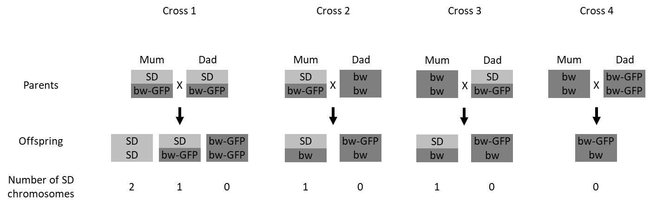  
  
-In the model, the difference between big K (0=no distortion, 1=complete distortion) and little k (0= negative distortion, 0.5=no distortion, 1=complete distortion) is confusing.

We have re-written the model in terms of small k, for consistency with the empirical work, to make things easier on the reader.

-The “wild type” comparison allele in these crosses is CyO, which is multiply inverted and has recessive lethals along with the dominant visible. I do not think this in an ideal comparison for fitness assays. It seems like there would be fitness costs of CyO. Did the authors account for this?

Actually, CyO was only used in Experiment 2, and not in our main results (i.e. the experiment shown in Figure 1). This was explained in the Methods, but it is hopefully more clear now that we have added the crossing diagram (which does not mention CyO; see above).

In Experiment 2, we did use CyO as the comparison allele. Although it is true that CyO is not representative of the ‘wild type’, it has other advantages that motivated us to use it despite this shortcoming. Firstly, CyO is reportedly insensitive to meiotic drive, which is useful because we wanted to collect non-SD progeny from SD-carrying fathers, and non-SD progeny were rare when using wild-type chromosomes in our other experiments (due to meiotic drive). Secondly, CyO is a balancer chromosome, and we wanted to prevent recombination in SD heterozygote mothers, in order to remove the recombination problem that affected the juvenile fitness assay in Experiment 1. Thirdly, we mostly found that SD is even more costly to larval survival than CyO is. Thus, any fitness costs of SD recorded in Experiment 2 are likely to be an underestimate, since CyO has somewhat reduced survival relative to wild type. **We now state our reasons for choosing CyO more clearly.**

-Perhaps a supplemental figure diagramming the genotypes including a summary of inversions and previous reports about lethals/sterile mutations for SD chromosomes will help readers. Looking at the approximate inversion breakpoints on these chromosomes, it is not totally surprising that there were recombinants.

In the original draft, we referenced the following chromosome diagram, which appears as Figure 1 in an earlier paper (it is the definitive review paper about SD; Larracuente and Presgraves 2012, *Genetics*):



We don’t think it would benefit our paper to copy or re-draw this figure, since the arrangement of inversions in SD is not essential to the main question of our study, e.g. “is SD costly to fitness, and are the costs recessive or dominant”? Also, we did already include a summary of what (little) is known about inversions and lethal mutations in SD in the Introduction. Here is the relevant section:

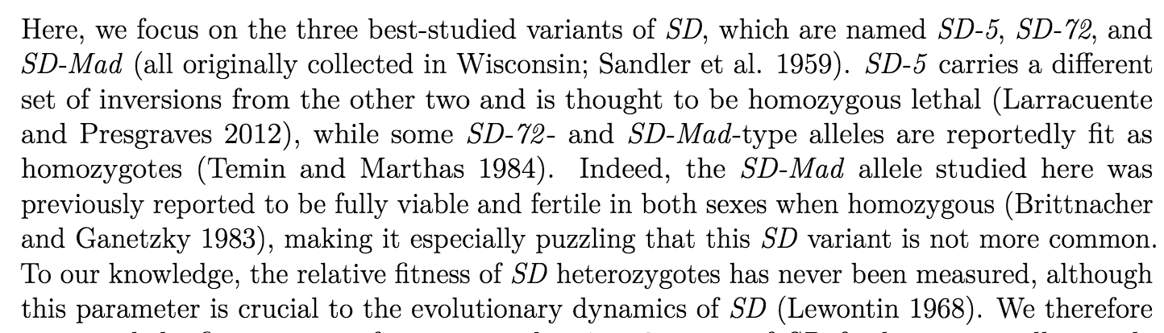

-I wonder how many eggs never hatched into larvae before the larvae-to-adult viability assays. Did the authors measure this? Apologies if I missed this information.

We did not count the exact number of eggs, because female flies lay a lot of unfertilised eggs, making it difficult to accurately measure juvenile survival during the embryo stage, since the unfertilised eggs look the same as fertilised eggs which died. This is one reason we began the larval survival assay with L1 larvae instead of eggs (**we now state this explicitly** **in the Methods**). However, the starting number of fertilised eggs was over 600 per SD variant (**now stated explicitly in the Results**). Unfortunately, we were not able to successfully determine the genotype of each individual until it hatched into a larva (see Methods), so we cannot reliably measure the survival of each SD variant in the egg stage (since we cannot assume that 50% of the eggs carry SD, due to meiotic drive, and we also cannot perfectly measure meiotic drive strength without knowing the relative survival rate). We are very careful to spell out what our results can show and what they cannot, e.g. we refer to “L1 larva-to-adult survival rate” instead of “% eggs reaching adulthood”.

Thus, the number of eggs that hatched was 40 out of 600+ (SD-5), 600 out of 600+ (SD-72), and a similarly large proportion for SD-Mad. So we can say that most eggs hatch for the latter two, and most eggs die for the SD-5, but we cannot be more precise than that.

-Did the authors check for drive in the males for each cross scheme? I didn’t see this reported in any of the tables. The X chromosome and 3rd chromosome can carry suppressors that I imagine would impact fitness.

Yes, we did run a pilot study which confirmed that the SD chromosomes drive when paired with the genetic background that we used in Experiment 1. We didn’t include these pilot data in the original submission because A) it is already well-known that SD chromosomes cause gene drive in most genetic backgrounds, and B) one can infer that SD did cause gene drive from Figure 1. This is revealed by the fact that the estimates are noisier for instances where the father had SD but the offspring did not: this is because non-SD progeny are rare due to the strong meiotic drive in the father, so the sample size is lower (this is explained in the paper).

We are aware that *trans*-acting suppressors have been discovered on chromosomes X and 3, and the reviewer is absolutely correct that these suppressors might affect fitness as well as affecting gene drive (this would be interesting to study in the future). However the flies used in our experiments all came from inbred lab stocks (see Methods and the crossing diagram), so it is unlikely that any of our stocks are genetically polymorphic for suppressor alleles. The pilot study supports this assertion, because strongly non-random segregation was observed in 45/45 families in which the father carried SD. So, our population apparently does not carry a strong suppressor (because if it did, we would not observe gene drive), and if any suppressors *are* present, they are fixed rather than polymorphic because the strength of gene drive was similar in all 45 families we tested.

**To address this concern, and to make available the pilot data for researchers who might be interested,** **we now include them in the study**. Here is the new figure, showing that roughly 80-90% of the adult progeny of SD heterozygote fathers carry SD (instead of the usual Mendelian 50%). Note that these estimates only provide a lower bound on the strength of gene drive, because it is possible that the survival rate is lower for SD-bearing progeny (this pilot experiment was not designed to simultaneously measure the effect of SD on egg-to-adult survival).

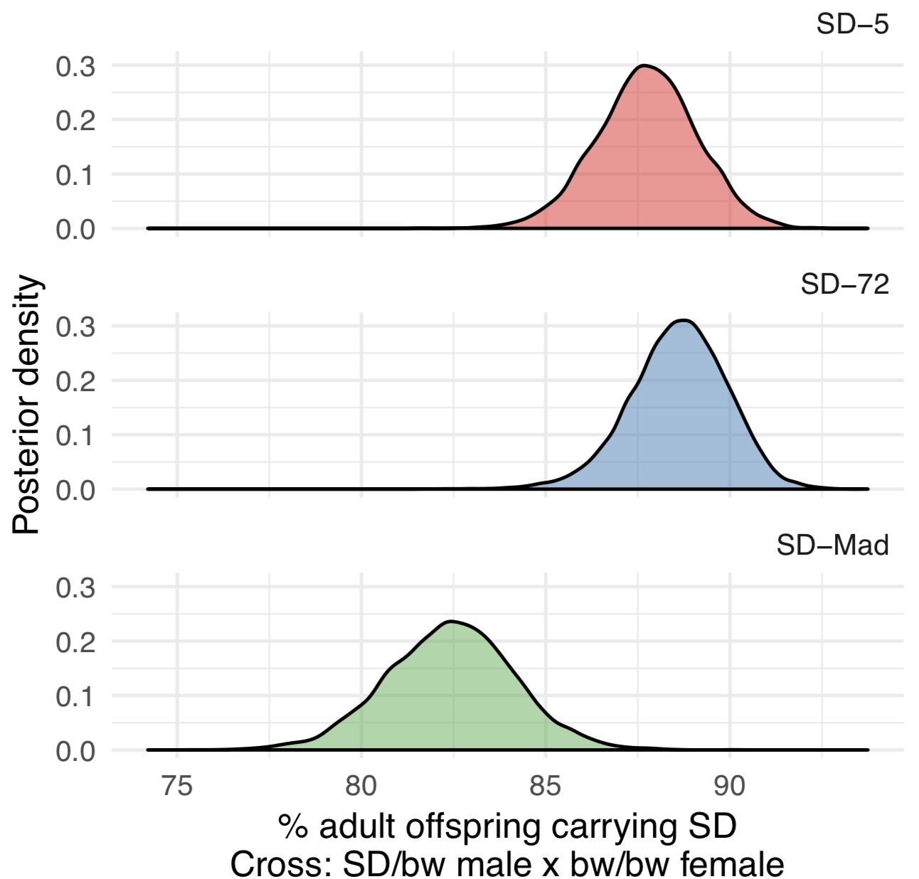

***Figure S2***: Posterior estimates of the percentage of adult progeny that carried SD in the pilot experiment, which crossed *SD/bw* males and *bw/bw* females. All estimates lie well above the 50% expected under Mendelian inheritance, and the estimate for SD-Mad is significantly lower than the other two. Note that the elevated percentage of SD progeny is the net result of segregation distortion and pre-adult mortality, and so the strength of segregation distortion might be stronger than suggested by these estimates if SD progeny are less likely to survive to adulthood.

Line 373: “polmorphism” should be “polymorphism” and Figure 1 legend: “statistcal” should be “statistical”

Many thanks, we have fixed these typos.

Running title should perhaps be “Fitness effects of a selfish gene complex” rather than “gene”

Thanks, we have changed the running header to “Fitness effects of a selfish supergene” for consistency with the title (“gene complex” and “supergene” have equivalent meanings)